Recipe

Chicken Salad Pie

Recipe

Mocha Brownies

Directions

\*This recipe is for TWO pans. Cut in half for just one.

BROWNIES:

1. Cream butter & sugar then add in eggs, one at a time
2. Add melted choc., then vanilla and flour
3. Pour into 9 x 13 pan
4. Bake 325 for 40 min.

ICING:

1. Mix all above then add in about 8-10 oz. of brewed coffee.
2. Spread over cooled brownies.

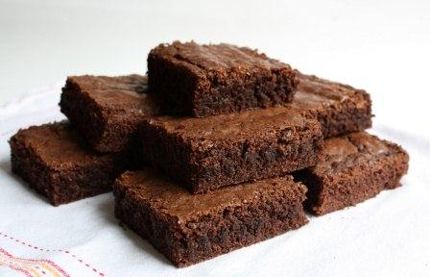

Ingredients

BROWNIES:

* 4 sticks butter (softened)
* 4 cups sugar
* 8 eggs
* 8 oz. unsweetened chocolate-melted
* 2 Tbsp. vanilla
* 2 ½ cups all purpose flour

ICING:

* 4 sticks butter (softened)
* 10 cups powdered sugar
* 1 tsp. salt
* 2 Tbsp. vanilla
* ½ cup cocoa

Directions

1. Mix all of the above except for the pie shells.
2. Pour mixture into two frozen pie shells.
3. Bake 350 for 20-30 minutes.

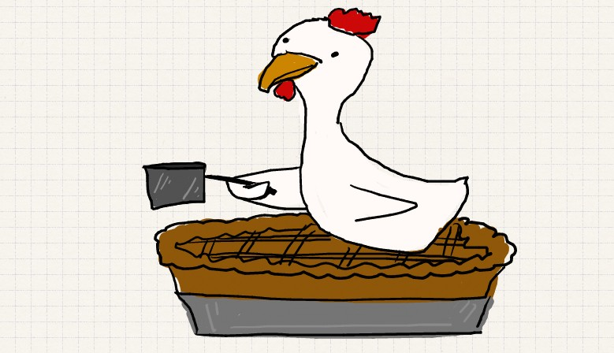

Ingredients

* 4 cooked chicken breasts-chopped
* 1 can cream of mushroom soup
* ½ cup mayo
* 1 small onion-chopped
* 1 can water chestnuts-chopped
* 3 stalks celery-chopped
* ½ cup grated mild cheddar cheese
* 1 Tbsp. Dill Weed
* 1 Tbsp. Celery Seed
* S & P to taste
* Two Frozen Pie Shells